**Mustaq Ahmad Lone**

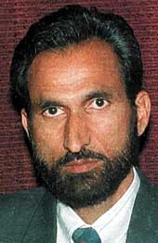

**About:** On 11th September 2002, an election rally of the State Law Minister, Mr. Mushtaq Ahmad Lone was attacked by a terrorist group which managed to assassinate the Minister who was a candidate from the Lolab constituency of Kupwara district. The election for this constituency had to be postponed to 8th of October 2002.

**Murdered on:** 11th September 2002.

**Attack details:** A terrorist group gunned down another independent candidate from Handwara constituency. Mushtaq Amhad Lone, law minister in the Jammu and Kashmir state government, was among 18 people killed on Wednesday in a wave of attacks carried out by militant separatists fighting Indian rule.

.**Reason to him target:** Militants chose September 11 to send a chilling message against elections in Jammu and Kashmir, mowing down law minister Mushtaq Ahmed Lone and 15 others in two strikes.

**Occupation:** State Law Minister.

**URL:** <http://news.bbc.co.uk/2/hi/south_asia/2253360.stm>

<https://www.telegraphindia.com/india/minister-killed-in-pro-poll-pocket/cid/866232>

